**DAILY ONLINE ACTIVITIES SUMMARY**

|  |  |  |  |  |  |  |  |
| --- | --- | --- | --- | --- | --- | --- | --- |
| **Date:** | **06/06/2020** | | | | **Name:** | **Anusha. K** | |
| **Sem & Sec** | **4th SEM 'A' Section** | | | | **USN:** | **4AL18CS009** | |
| **Online Test Summary** | | | | | | | |
| **Subject** | | **Data communication** | | | | | |
| **Max. Marks** | | **30** | | **Score** | | **28** | |
| **Certification Course Summary** | | | | | | | |
| **Course** | **Introduction to full stack development** | | | | | | |
| **Certificate Provider** | | | **greatlearning academy** | **Duration** | | | **8 hours** |
| **Coding Challenges** | | | | | | | |
| **Problem statement 1:Write a program in C to rotate an array by N positions.**  **Problem statement 2:**Write a Java Program to find the second-highest number in an array.  **Problem statement 3:Given an array A of size N containing 0s, 1s, and 2s; you need to sort the array in ascending order.** | | | | | | | |
| **Status: completed** | | | | | | | |
| **Uploaded the report in Github** | | | | **yes** | | | |
| **If yes Repository name** | | | | [**https://github.com/anusha20219/Lockdown-coding**](https://github.com/anusha20219/Lockdown-coding) | | | |
| **Uploaded the report in slack** | | | | **Yes** | | | |

ONLINE TEST DETAILS: Data communication test was conducted from 9:30 am to 10:15 am . There were 30 questions and time duration was 45 minutes. The questions were mcq type.

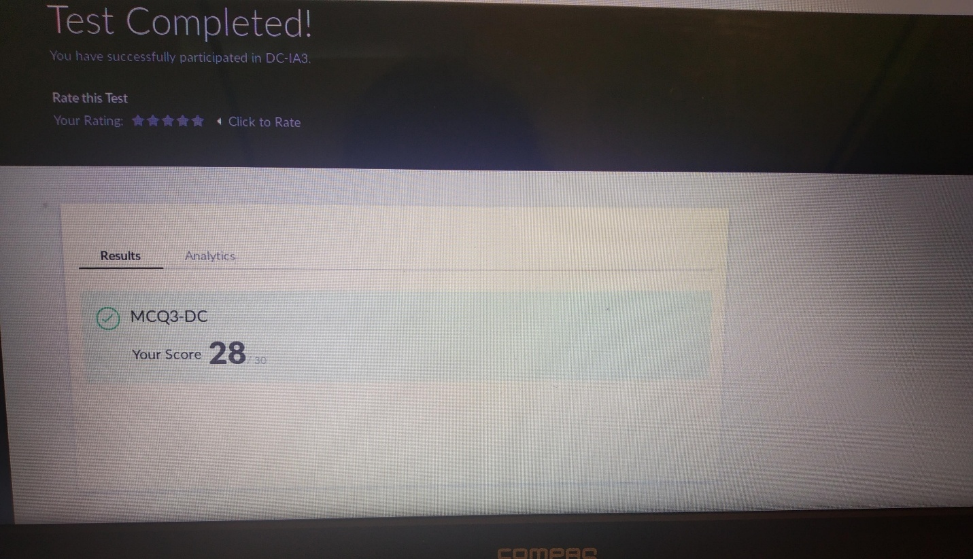

CERTIFICATION COURSE DETAILS: Today I studied about absolute and relative paths, air attributes, ordered and unordered lists, Introduction to input elements, forms, method attributes, html attributes.

Coding challenge details:

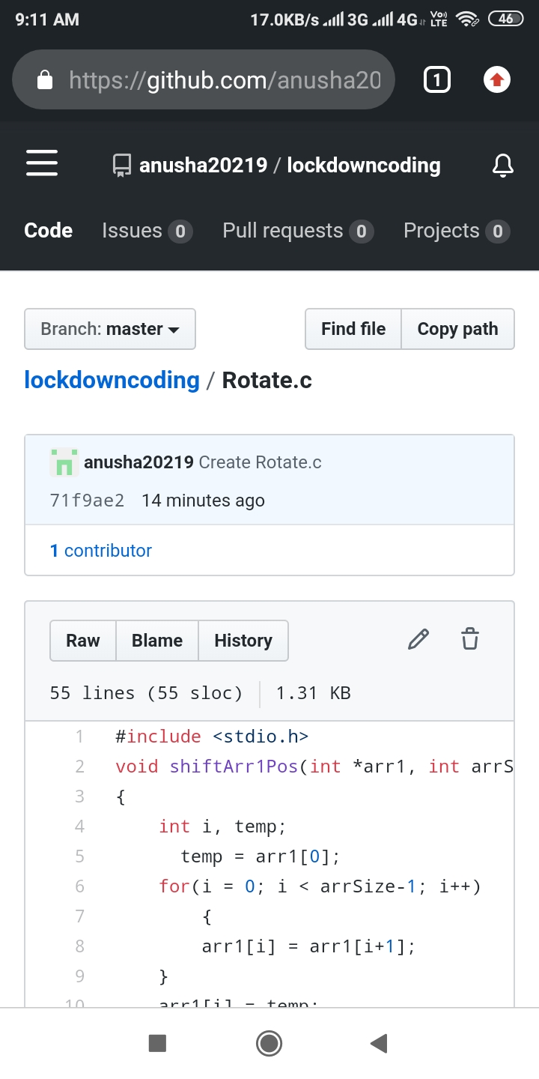Problem statement 1: write a program in c to rotate an array by N positions.

Problem statement:2

Write a Java Program to find the second-highest number in an array.

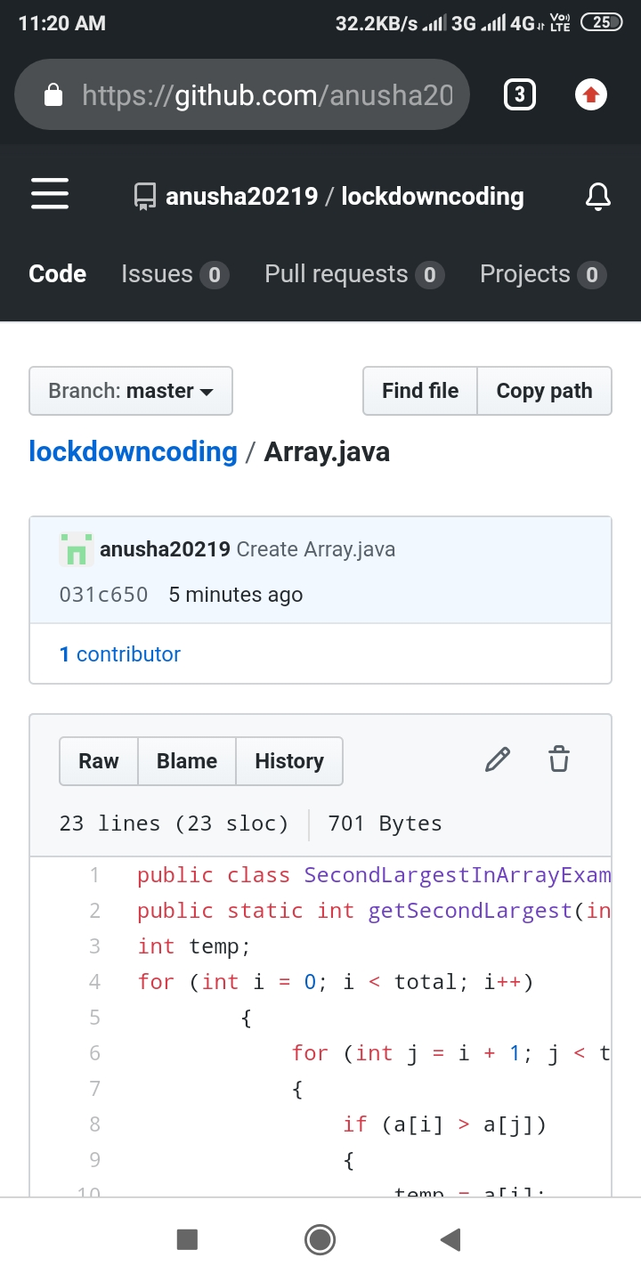

Problem statement:3

Given an array A of size N containing 0s, 1s, and 2s; you need to sort the array in ascending order.

Input:

The first line contains an integer ‘T’ denoting the total number of test cases. Then T testcases follow. Each testcases contains two lines of input. The first line denotes the size of the array N. The second lines contains the elements of the array A separated by spaces.

Output:

For each testcase, print the sorted array.

Constraints:

1 <= T <= 500

1 <= N <= 106

0 <= Ai <= 2

Example:

Input :

2

5

0 2 1 2 0

3

0 1 0

